**Contract: 6 month fixed term contract**

**Salary dependent on skills and experience**

Marylebone Cricket Club (“the Club”) is the world’s most active cricket club, custodian of the Laws of Cricket and is also the owner of Lord’s Ground, the “Home of Cricket”. The MCC and Lord’s brands are renowned worldwide and are synonymous with excellence, prestige and providing an enjoyable customer experience, whether at an international cricket match with 28,500 spectators, or for Sunday Afternoon Tea in the Long Room.

An opportunity has arisen for a motivated individual to join the Retail and Merchandising Department on a sixth-month fixed-term contract as a Retail Assistant.

Our main retail operation trades all year round - with additional in-Ground shops operating throughout the summer months. All shops offer a wide range of sport and leisure clothing, replica playing kit, souvenir merchandise and gifts for everyone – purchases made as a memento of a great Lord’s experience.

This position is primarily a shop floor-based role and an integral part of the retail operations team. You will be helping run the in-Ground retail shops and stockroom functions to ensure efficiency and profitability. Mandatory attendance on all major International and domestic match days is part of this position as is occasional weekend working where, after a period of training, opportunities can become available to take on operational responsibilities.



Candidates are likely to have at least one year of recent retail experience and will be able to explain and demonstrate what excellent customer service looks like. You must be able to communicate confidently and converse with all types of customer, be highly organised and willing to take instruction when needed, while also having the ability to work with initiative and independently.

Key Skills

* Excellent customer service skills with a guest focussed attitude
* Punctual and willing to be flexible
* Confident, outgoing and enthusiastic
* Trustworthy, hardworking and reliable
* Excellent communication and English language skills
* Able to work independently, without supervision
* Experience of working in a customer facing role, at an event, or in a similar environment
* Working within the stock room environments to ensure sufficient flow of product to shop floors
* Assisting with intake of deliveries
* Reporting discrepancies and problems to a supervisor

Employees work a 35 hour week on a rota system operating over a full, 7-day trading week, plus extended hours on all Major Match days. Flexibility is therefore essential.

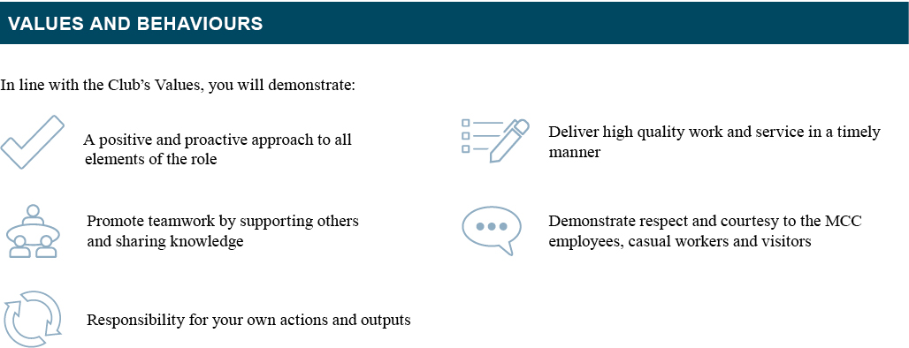

In line with the Club’s culture, you will:

* Have a positive and proactive approach to all elements of the role.
* Take responsibility for own actions and outputs.
* Be respectful to all MCC employees, casual workers, Members and visitors.
* Actively promote team work by supporting others and sharing knowledge.
* Deliver high quality work/service in a timely way.
* Actively work to help improve standards across the Department.

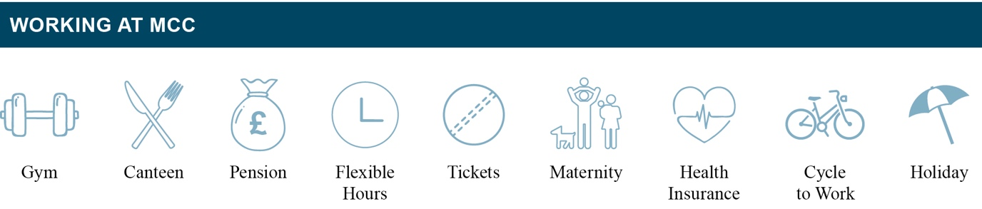

*Skills and ability testing will form part of the selection process.*

Please email your CV and a covering letter, stating salary expectations, for the attention of Jemma O’Leary, HR Manager at [jobsatlords@mcc.org.uk](mailto:jobsatlords@mcc.org.uk)

**Closing Date**: **TBC**