MCC Copyright and Copying Policy
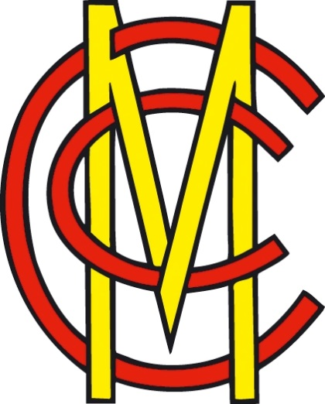

Introduction
MCC’s collections are intended to promote international appreciation of cricket history and heritage by providing access to objects, information and advice for the learning and enjoyment of the widest possible audience, as well as to develop, interpret, conserve and safeguard the collection to the highest possible standards.

In some cases, our audiences will wish to obtain copies of our material for various purposes. This could include personal use, non-commercial research, or reproduction for publications. However, we cannot allow all of our material to be copied. Although we may own the physical version in our collections, such as a letter, book or photograph, this does not mean that we have the right to do whatever we wish - the copyright rests with the person who created it, whether it be the author, photographer or artist.

This guide intends to help decide on what material can and cannot be reproduced for MCC members, researchers and the general public. It is not meant to constitute legal advice.

If you have any questions please contact the MCC Library at mcclibrary@mcc.org.uk or telephone 0207 616 8559.

What is Copyright?
Copyright is part of a series of ‘intellectual property rights’ that gives the owner the right to control the use of certain kinds of their ‘work’ which are the consequence of the author’s skill, time and effort by the owner. It is created automatically, as soon as a work is created, and is divided into various categories:
- Literary works – written works, including letters, numbers or symbols. For the MCC Collections, this would apply to books, reports, lists, scorecards, fixture cards and correspondence.
- Dramatic and musical works – works to be performed including plays and choreography, and works of music. The MCC Archive holds a collection of cricket sheet music.
- Artistic works – applies to two-dimensional objects such as maps, drawings, paintings and photographs, or three-dimensional objects such as sculptures and medals, all of which are held within the MCC Collections.
- Films – works include videos and DVDs. Films made before 1 June 1957 were not protected as films but as sequences of photographs. The MCC Archive contains films, videos and DVDs, which are in copyright.
- Sound recordings – the recording of sounds is protected not the work. The MCC Archive contains sound recordings including the MCC Audio Archive (an interview project established in 2003) and cricket music.
- Typographical arrangements – in other words, the layout of a page; for example MCC-headed letter paper is our copyright, as it consists of a combination of headings and logos.
How long does copyright last?
Firstly, with any work, a decision needs to be made between whether a work has been ‘published’ or ‘made available to the public’:
- A work has been ‘published’ if, with the approval of the copyright owner, multiple copies have been issued to the public or made available online. So this applies to the majority of our Library collection, rare books, but not correspondence or manuscripts.
- A work has been ‘made available to the public’ for the purposes of duration if it has been given exposure to the public. For MCC, this would be applicable to items we produce such as scorecards, menus, brochures, fixture cards.
- For films, the standard term of copyright in films is 70 years after the death of the last to die of the principal director, the authors of screenplay and dialogue, and the composer of music.
- For sound recordings, the standard term of copyright is 50 years from the year of creation or of publication.
Who owns copyright?
The owners of copyright will be:
- The author – the person who created the work and was responsible for its contents.
- The employer – if the work was produced by an employee in the course of employment. For example, for letters produced by MCC staff in the course of employment, the copyright would rest with MCC.
- The producer and principal director jointly – in the case of a film.
- The producer of a sound recording – whoever initiated and financed the recording
- The person who commissioned and paid for the work – in the case of engravings, photographs and portraits commissioned before 1 August 1989. This applies to several (but not all) of our paintings, portraits and photographs commissioned, also for works created under the MCC Young Artist scheme.
Copying of Library material
- We may make and supply a single copy of a single article from a journal or a reasonable part of a published edition of a literary, dramatic or musical work, for the purposes of private study or non-commercial research. For books, ‘reasonable’ equates to either a chapter of a book, or 10% of the total number of pages within that publication.
- Whoever wishes to obtain the copy must sign a copyright declaration form for published material. Either the recipient of the copy or a member of the Library staff can fill in details on part 1, but the recipient of the copy MUST sign, date, and place their name and address in part 3.
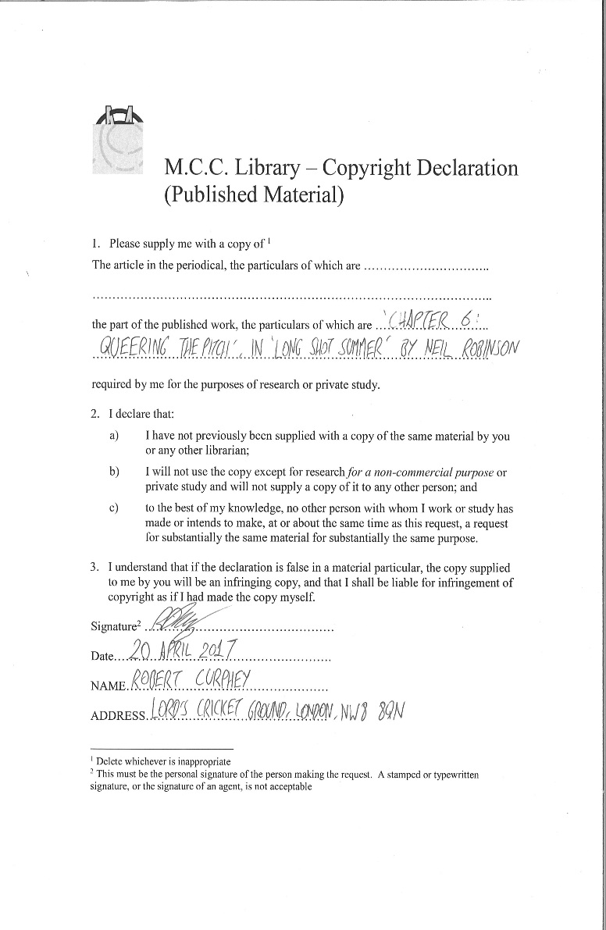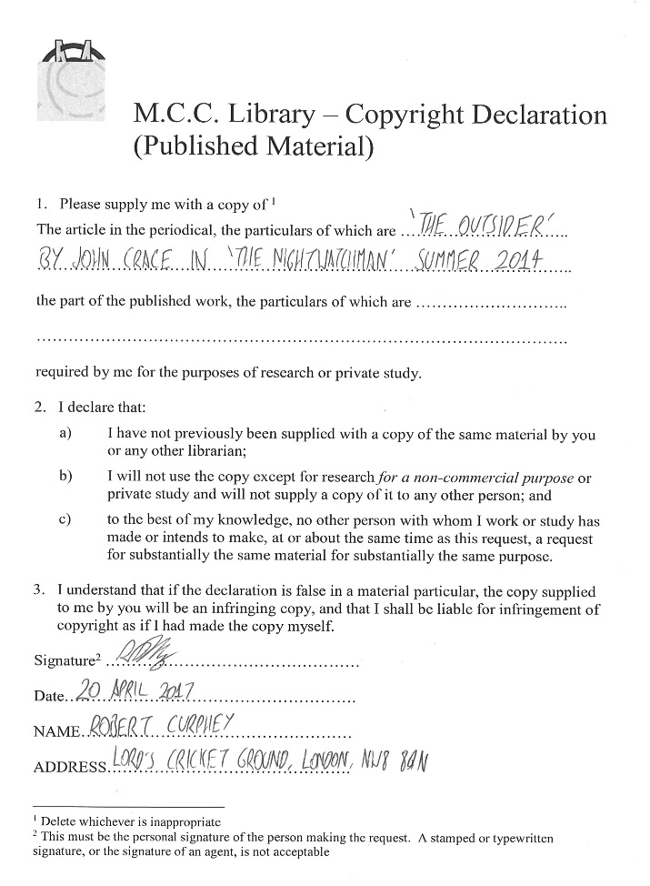
Copying can be done by either a member of Library staff or the recipient, but a member of staff must check the number of pages and calculate the cost before returning them to the recipient.

Copying of Archive material
- There is no limit to the amount of archival material that an individual can copy. However, a number of considerations may be taken into account, mainly, who owns the material. Although the item may be held by the MCC Archive, it may not necessarily mean we own the copyright unless specifically agreed as part of the item’s donation. Examples of this would be:
  - Correspondence sent to us – the copyright rests with the person who owned them.
  - Newspaper cuttings – the copyright rests with the newspaper.
  - Photographs – the copyright rests with the creator of the image.
  - Music sheets – the copyright rests with the composer of the work

The criteria used by MCC staff to decide whether material can be reproduced or not is based on advice from the National Archives, and this copyright flowchart available at http://www.bl.uk/reshelp/pdfs/copyrightflowchart.pdf

- The copying of items by MCC staff will depend on the following criteria:
  - Whether the author is known
  - The date the work was created
  - The date the work was published
  - The date the author died.
For example, a letter written by Lord Harris in 1908 could be copied, as the copyright to that letter would expire 70 years after the death of the author (Lord Harris died in 1932)
- However, we would permit photocopying of items created by MCC – provided that it is of suitable condition, is not confidential and does not fall within the Club’s 30-40 year rule of restricted access (see https://www.lords.org/history/mcc-museum-library-and-collections/mcc-archive/ for more information). The Librarian or Archivist should assess the contents of the material before allowing them to be reproduced.
Examples of this would be:
  - Correspondence issued by anyone acting on behalf of the Club, or as part of Club business. Any correspondence produced on MCC-headed notepaper.
  - Minutes of the MCC Committee, principal committee or sub-committees.
  - Reports or agendas compiled by MCC officials.
  - Scorebook entries of MCC matches, tours, outmatches and matches played at Lord’s (the 30-40 year rule does not apply to these documents as they are not organisationally sensitive).
  - Scorecards of matches at Lord’s (the 30-40 year rule does not apply to these documents, as again they are neither confidential or sensitive)
  - Menu cards of events held at Lord’s or by MCC

Example 1: Letter, Madelaine Gale to Ronald Aird, 21 May 1952 (from MCC/SEC/3/58: Colonel Rowan Rait Kerr, Ronald Aird)
Although the letter is in our collections, we did not create it and thus do not own the copyright. The copyright rests with Mrs Gale, and if the individual has died, then copyright would rest with his/her successor(s). Therefore, this cannot be reproduced.
Example 2: Letter, Ronald Aird to Madelaine Gale, 22 May 1952 (from MCC/SEC/3/58: Colonel Rowan Rait Kerr, Ronald Aird)
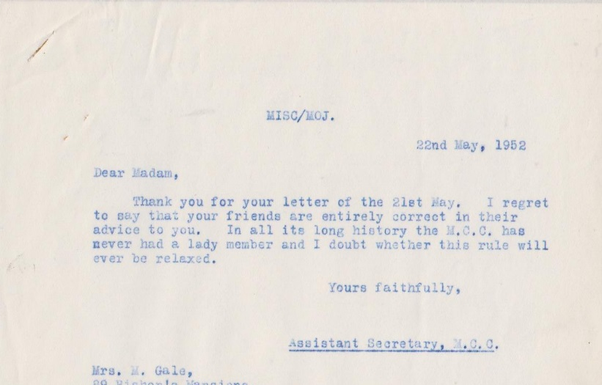
Ronald Aird was the then Assistant Secretary of MCC. As this letter was written as part of MCC business, the copyright rests with the Club. Therefore, this can be reproduced.

Example 3: Memorandum of Health Precautions, 1964 (from MCC/CRI/5/1/83/1: MCC tour of India file, 1963-1964)
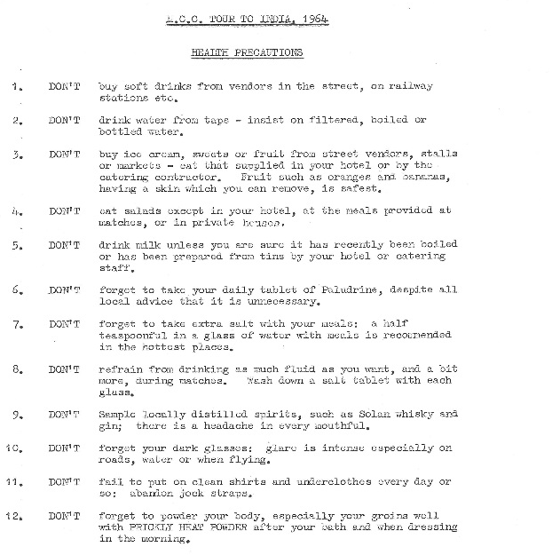
This can be reproduced as it falls within the conduct of official MCC business.
Whoever wishes to obtain the copy of an archive document must sign a copyright declaration form for unpublished material. Either the recipient of the copy or a member of the Library staff can fill in the details in the top part, but the recipient of the copy MUST sign, date, and place their name and address in the bottom section.

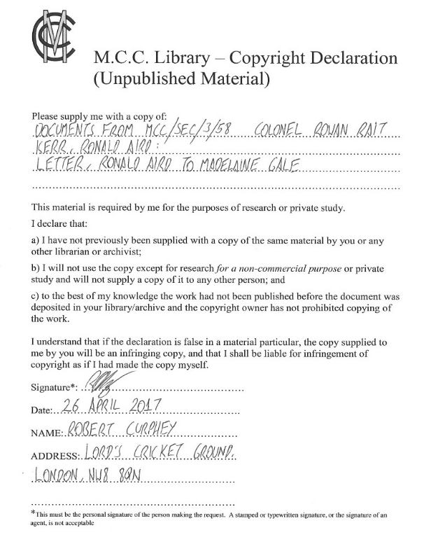
All copying of archival material must be done by a member of staff.
Using a camera to take digital copies
Researchers are permitted to take copies of our holdings on a digital camera provided that they fill in the above declaration forms indicating the material they wish to make copies of.
Copying of photographic items and artwork
Whether we are able to supply images depends on a number of factors:
- Whether the author of the image was recorded, both on the photograph or elsewhere
- The date the photograph was created
- The date the photograph was published
- The date the author died
The situation is, however, rather complicated when it comes to photographs taken before 1996. For all such requests, the following guide, compiled by the British Library, should be referred to:
http://www.bl.uk/reshelp/pdfs/copyrightflowchart.pdf
This guide is used by MCC staff to decide whether photographs can be used.
The more modern the image is, the less likely that we can use the image for reproductive purposes. Images that originally reside in published material cannot be copied under any circumstances.
For photographs / artwork commissioned by the Club, the following chart above should apply.
MCC Sport and General Collection
The Club has in its collection a number of photographs taken by the Sport and General Press Agency, an organisation which was since superseded by the Press Association. If photographs from the Sport and General Collection are requested by researchers for use in publication, then the individual must be urged to contact Press Association images for access.
Should a researcher wish to use any of these photographs they should contact Jon Harris at the Press Association:
jonathan.harris@pressassociation.com Telephone: 0115 851 2704
Press Association, Pearl House, Friar Lane, Nottingham, NG1 6BT
For photographs between 1972-2003, we would NOT have the copyright for images in the collection. Anyone wishing to obtain photographs should speak to a member of Library staff in the first instance.
Modern photographs of Lord’s
All requests for modern photographs / photographs of Lord’s Ground in its present form (after 2003) must be referred to Clare Adams, MCC Filming and Photography Manager:
clare.adams@mcc.org.uk Telephone: 0207 616 8522
Film copyright
We are allowed to show films/DVDs to researchers, on the sole condition that they are shown to one individual on a stand-alone computer terminal. This can be arranged at the MCC Library; please contact the Library for more information.

Costs for Photocopying
Should a researcher wish to obtain copies of our holdings, the following charges will be applied:
Photocopies of material
MCC Members = 10p per A4 sheet, 20p per A3 sheet
Non-MCC Members = 15p per A4 sheet, 30p per A3 sheet
Reproduction of images in publications and film
Books £70.00 plus VAT (20%) £14.00 £84.00
Book Jackets £100.00 plus VAT (20%) £20.00 £120.00
Newspapers (inside) £60.00 plus VAT (20%) £12.00 £72.00
Newspapers (cover) £100.00 plus VAT (20%) £20.00 £120.00
Television (max 6 sec) £60.00 plus VAT (20%) £12.00 £72.00
Magazines (inside) £70.00 plus VAT (20%) £14.00 £84.00
Magazines (cover) £100.00 plus VAT (20%) £20.00 £120.00
Trade & House Journals £50.00 plus VAT (20%) £10.00 £60.00
Academic theses £25.00 plus VAT (20%) £5.00 £30.00
- M.C.C. reserves the right to charge a search/handling fee of 25% at its own discretion. To save payment of this fee, researchers can view the collection in the M.C.C. Library by appointment.
- Licences for reproduction rights must name the image and are for one edition only.
- For further editions a minimum of 50% of the original fee is charged.
- M.C.C. permits a 15% discount for textbooks.
- All fees must be paid before the photographs are released.
- Correct acknowledgement must be made: MCC Library
- Reproductions to be used only for the specific purpose for which the application is made. Separate applications must be made for further reproductions of the same subject.
- M.C.C. will not accept responsibility for copyright infringement.

